Mr. Cadle moved into a new house last semester. His grandmothers wanted to see pictures, but he has no camera. Help him create a picture of the house by designing one in Processing. Make your sketch in an 800 x 600 window with a blue background. Since spring will be around the corner, make the yard green and situated 2/3 of the way down the screen. Place two oval shaped trees in the yard, one on each side of the house. Your trees should *not* have an outline around them since they are an organic shape. The house itself is sitting on the yard half way between the left and right edges. The shapes on the house will have a black outline around them. Mr. Cadle’s house has a brick exterior, so make the outside red. There should be one door and two windows on the front of the house. Make sure you leave enough room to add the decorative half circle above the door. The roof should be a triangle that hangs off both sides of the house so no rain gets on the brick. Next there should be a chimney sticking out of the back of the house (shape’s base should not be visible). Finally add two more shapes of your own design to the drawing to make it unique. Here’s an example to get an idea of what Mr. Cadle wants:

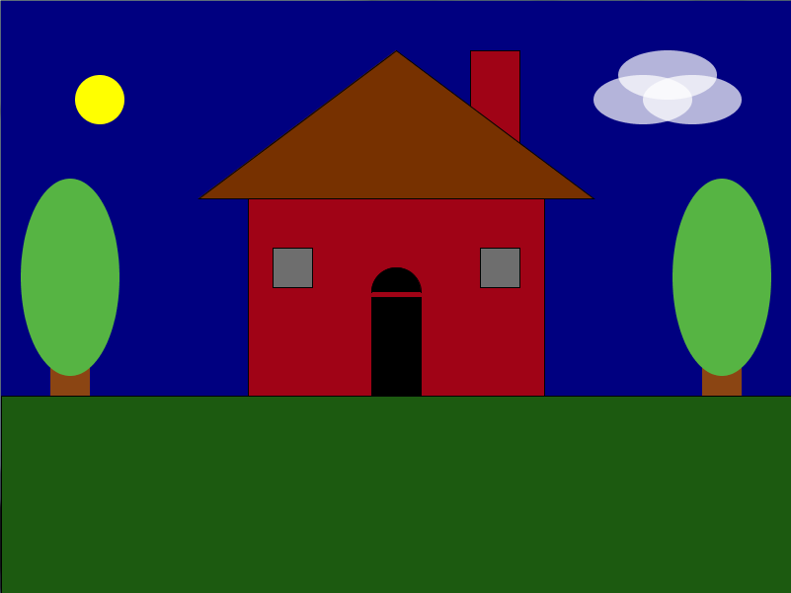

Make sure that you use the correct command to make the rounded shapes smooth, not blocky. Also, this will be an interactive sketch someday, so make sure that you use the appropriate methods to make this sketch interactive and not static.